**Ayush Raj**

**22BRS1117**

**Lab Assignment**

**Creation and Migration of Database in Aws**

Creating a database

Process are as filliws

* click on create database

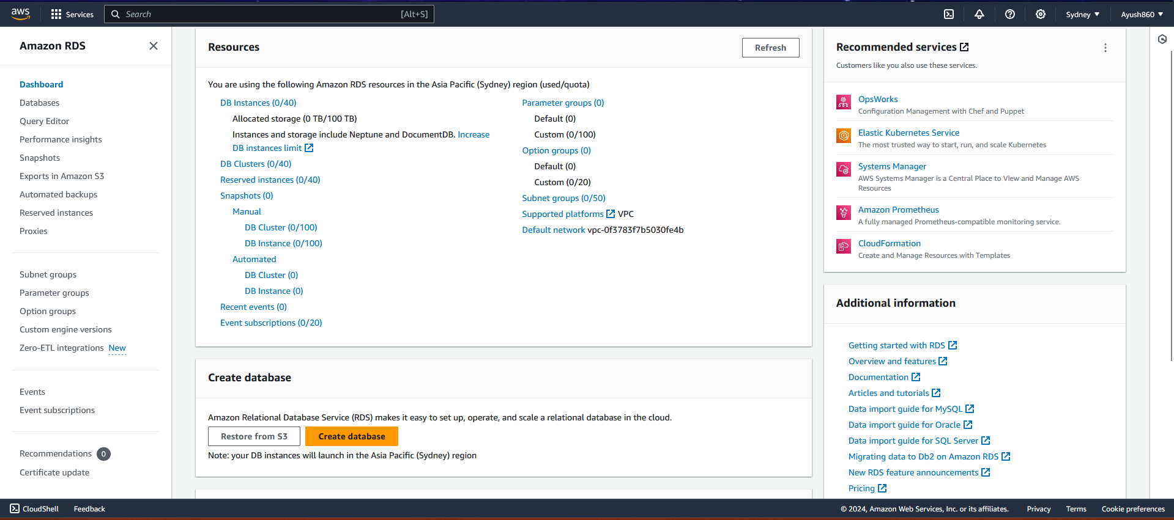

* choose the type of console and type of database

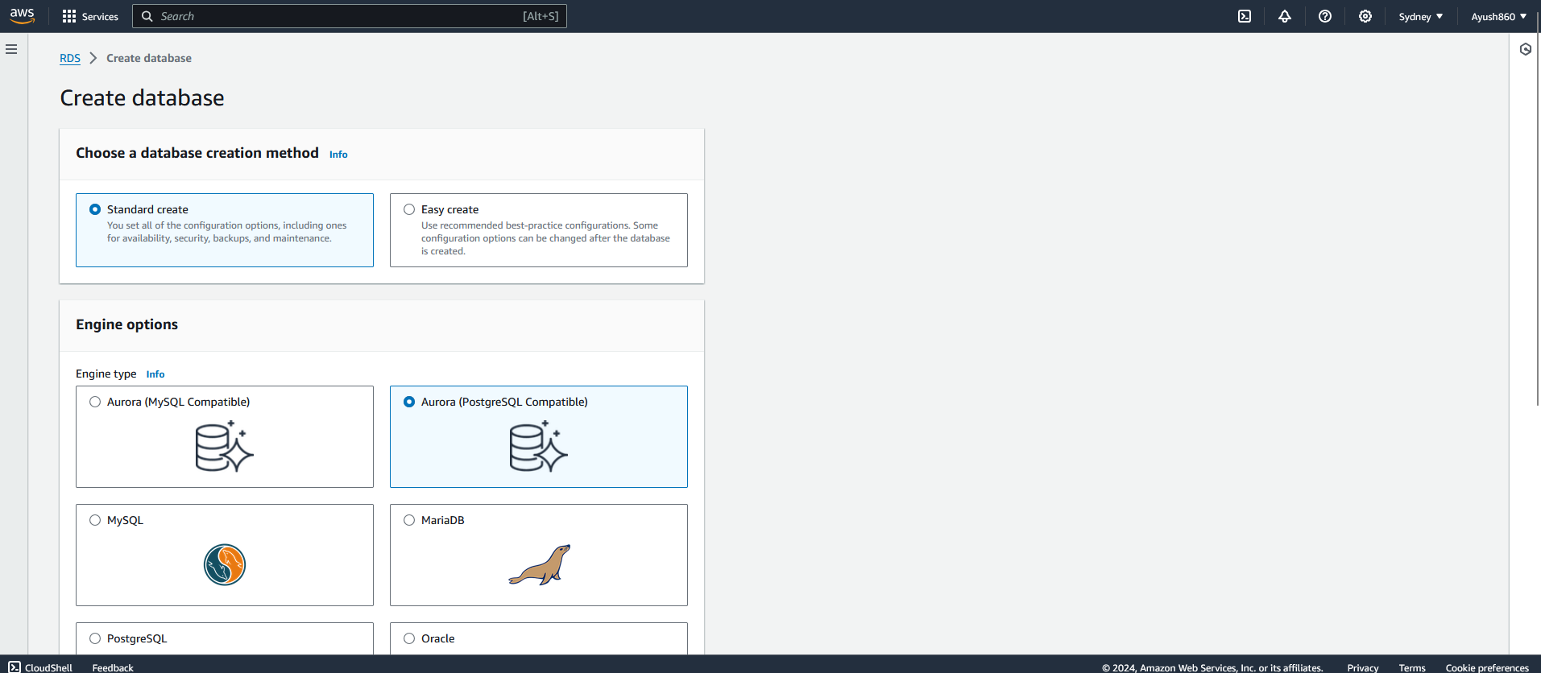

* click on engine version and rds extension support

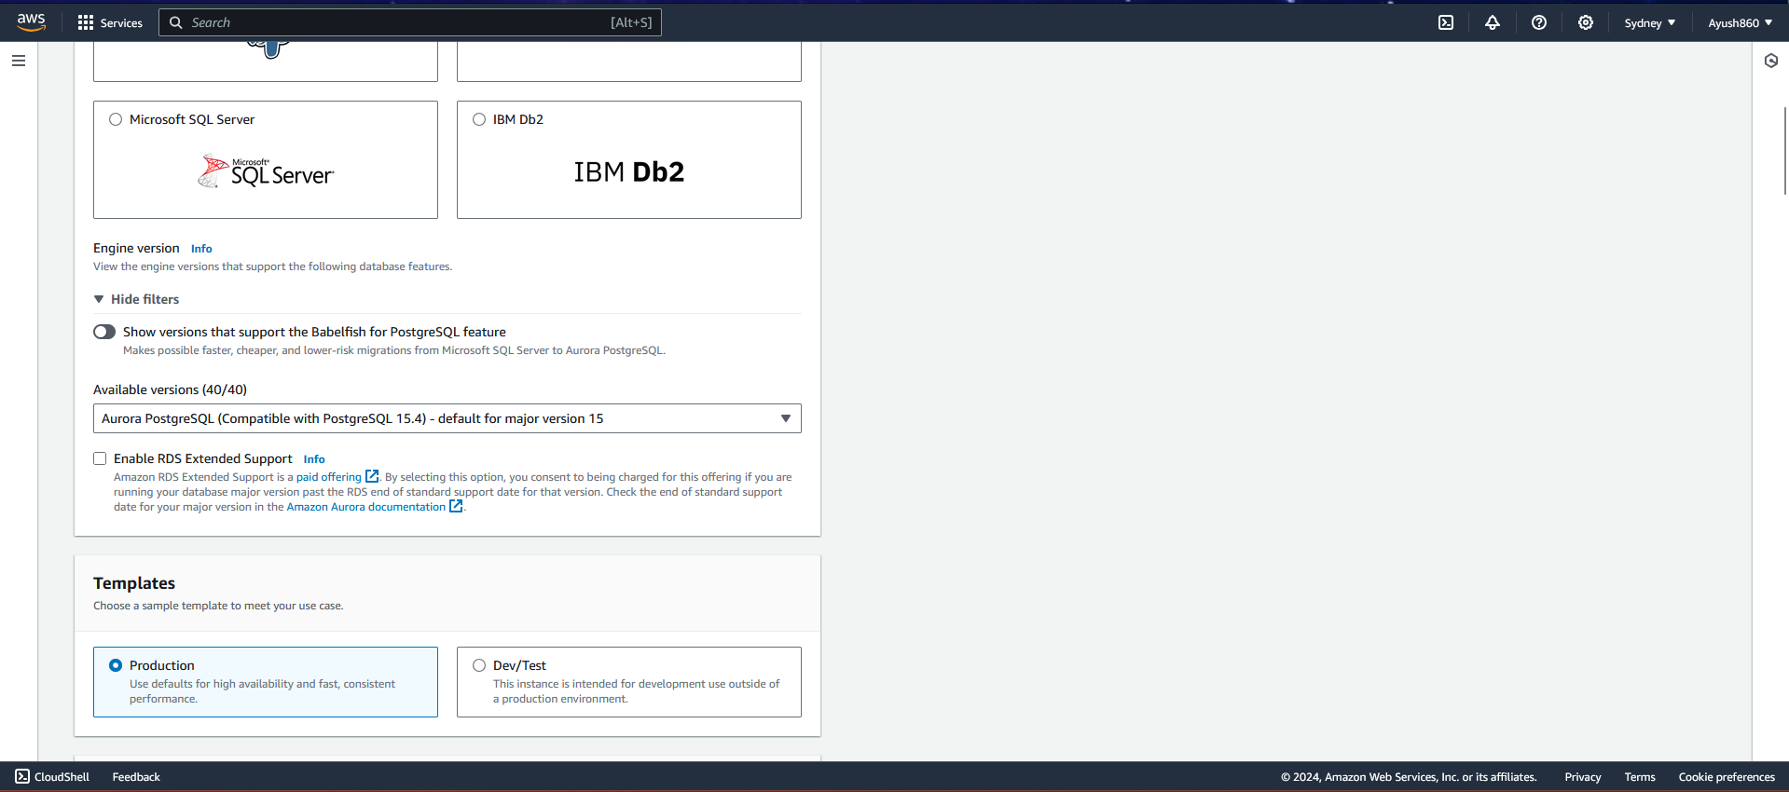

* template for production choose dev and test



* cluster storage configuration and instance configuration

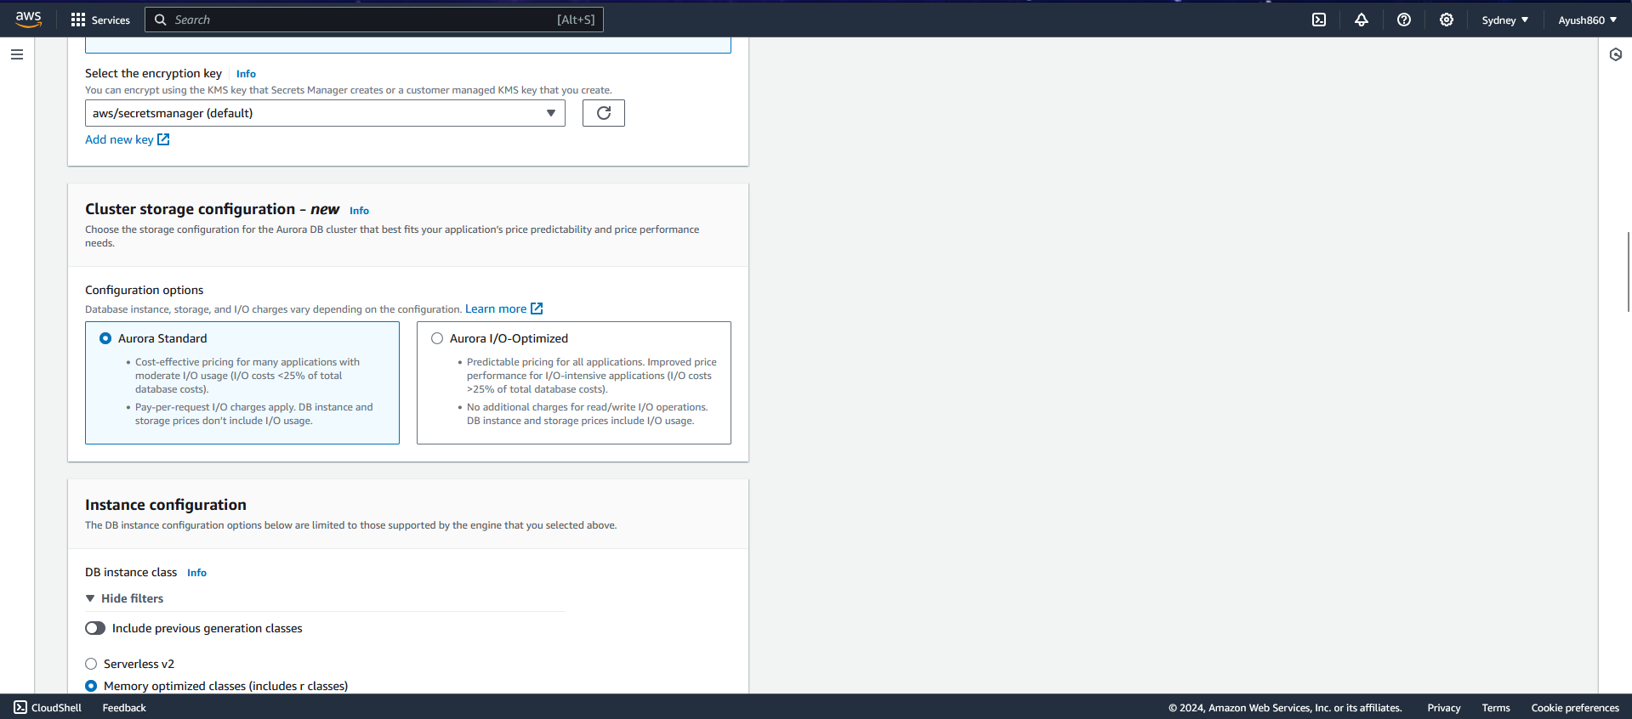

* availability and durability, connectivity

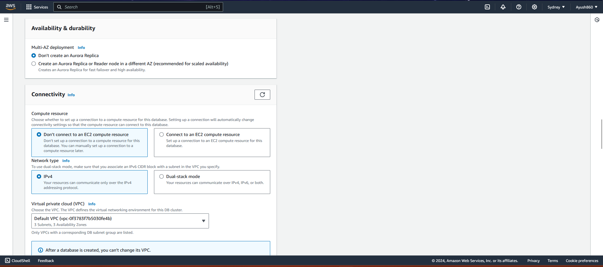

* security group and choose existing security groups

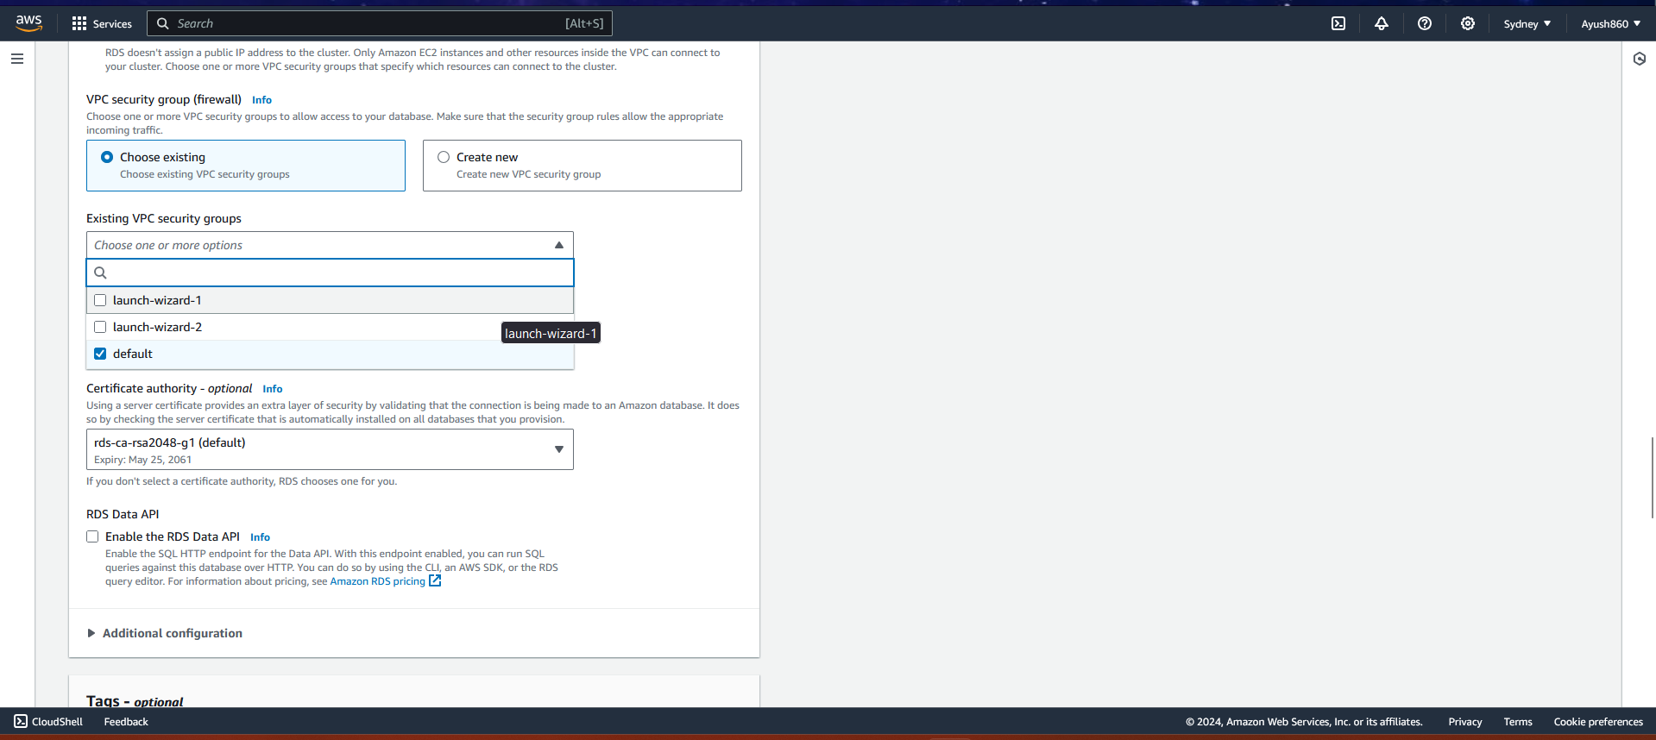

* aws key management

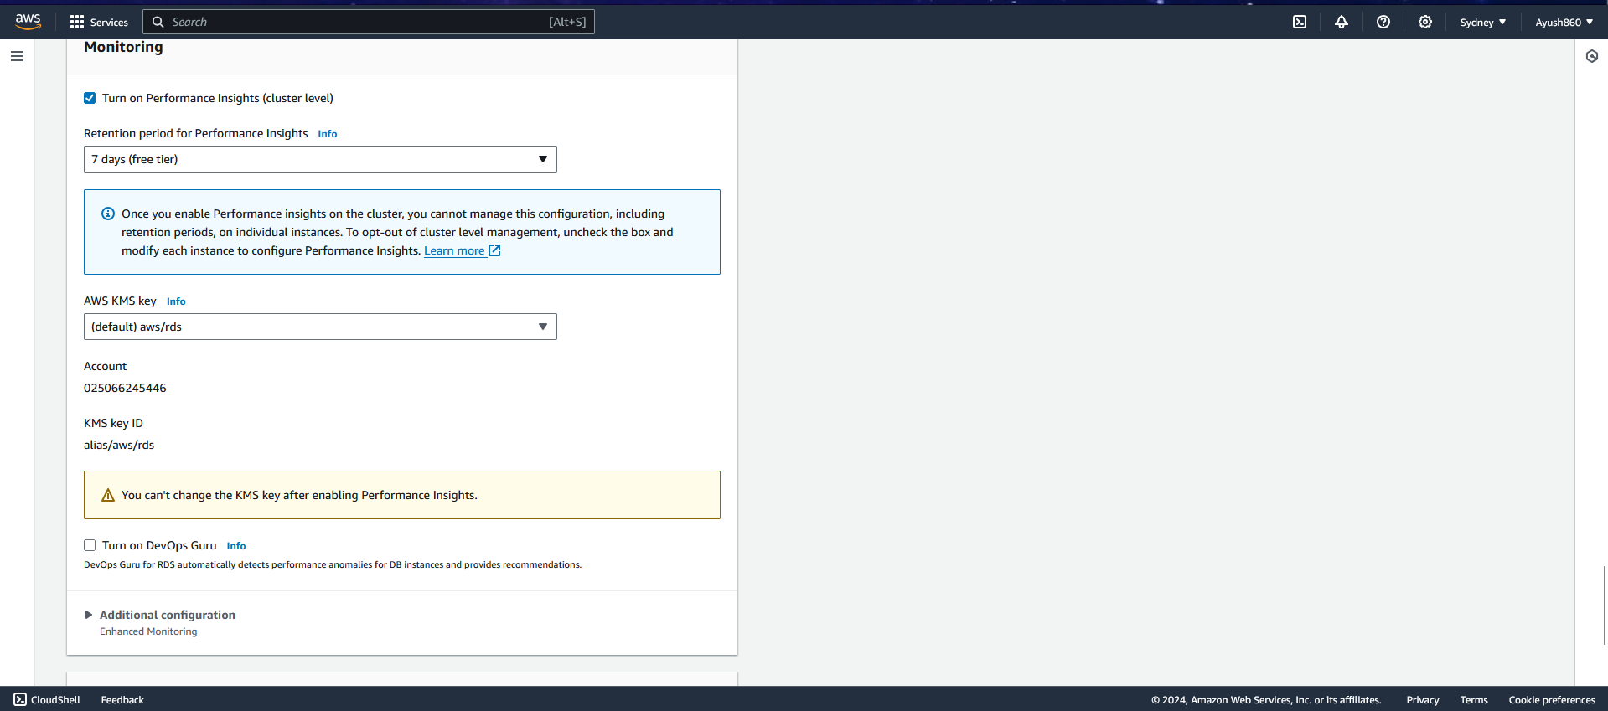

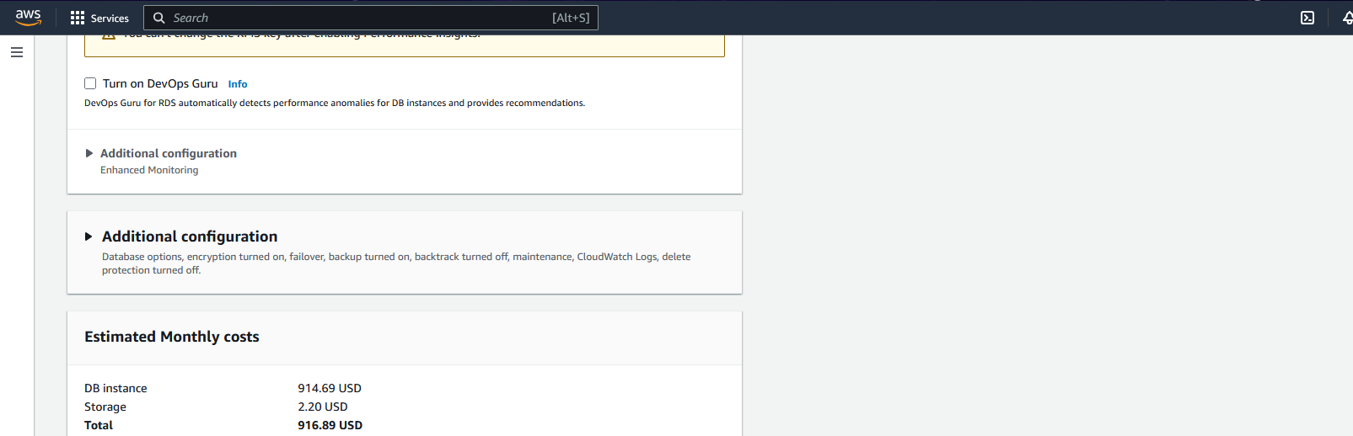

Click on create database

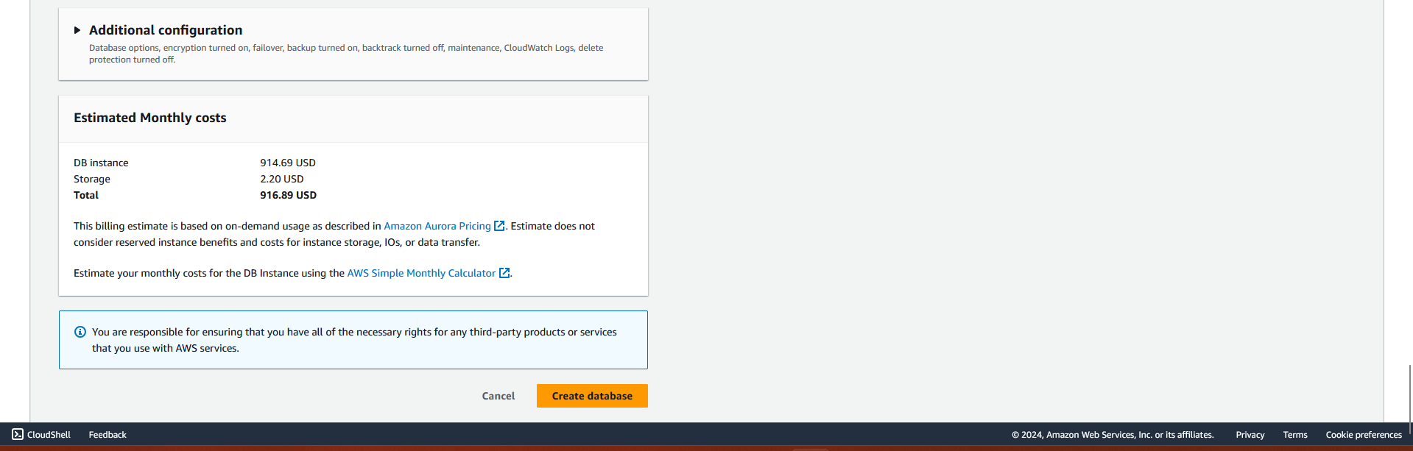

Migration of databse using database migration system

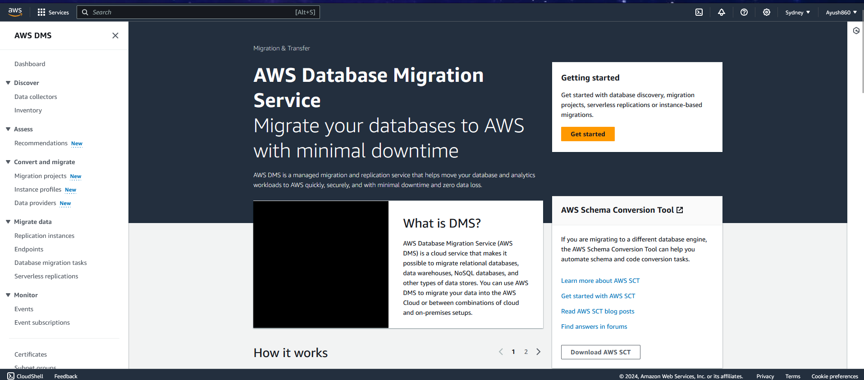

Click on get started

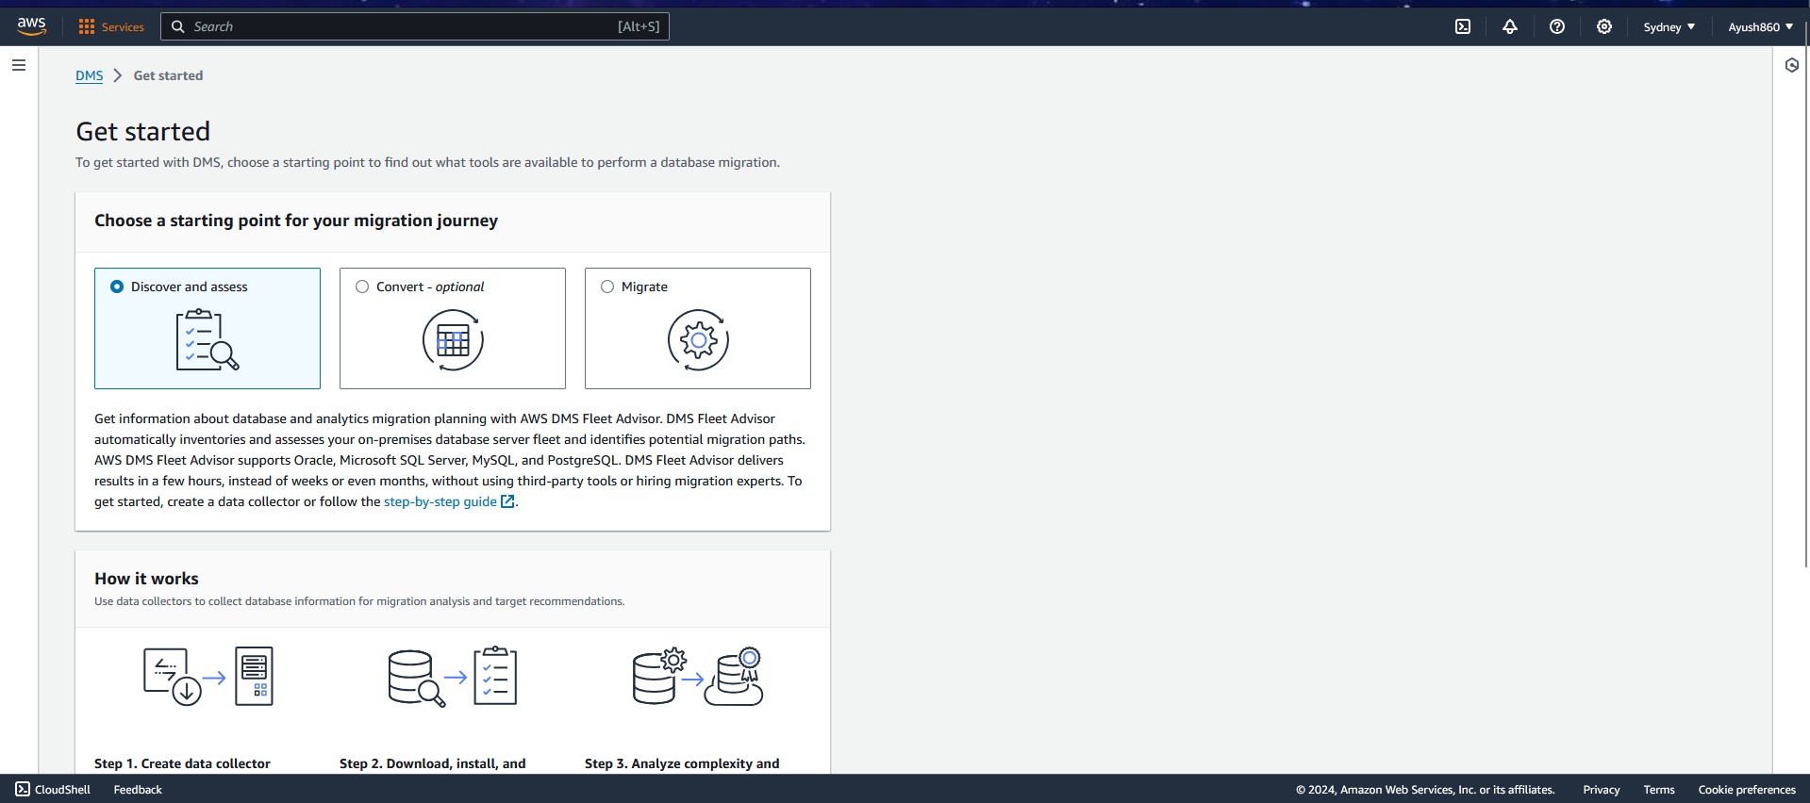

Click on create data collector

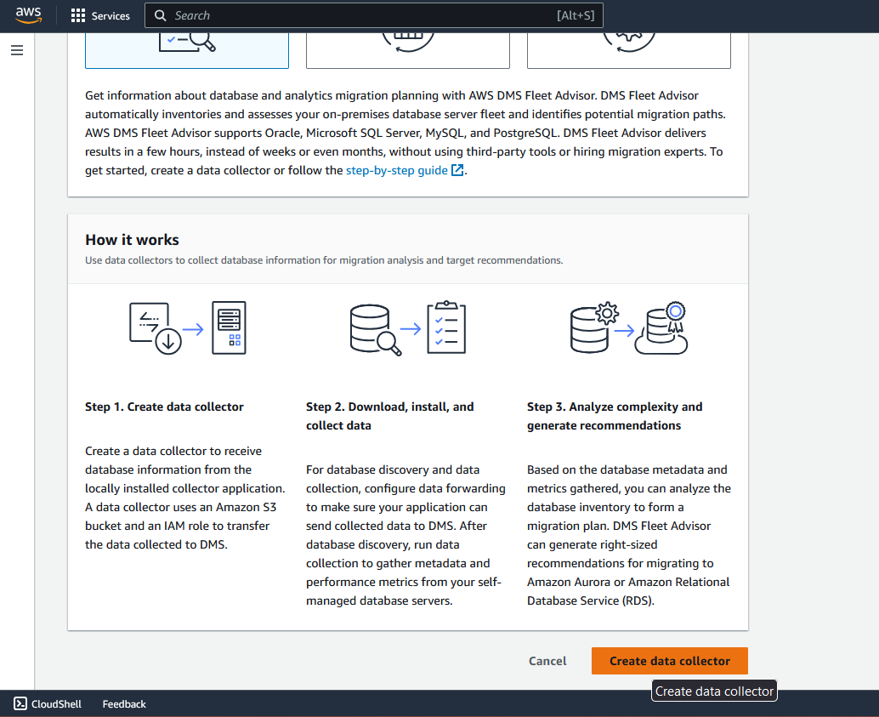

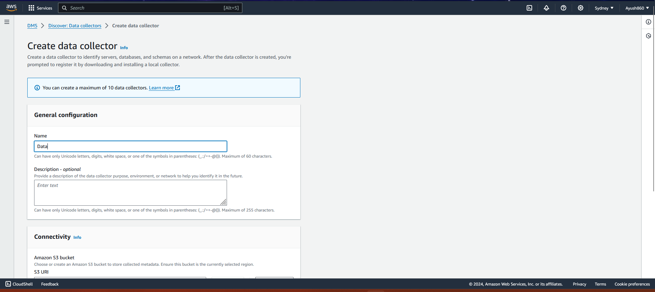

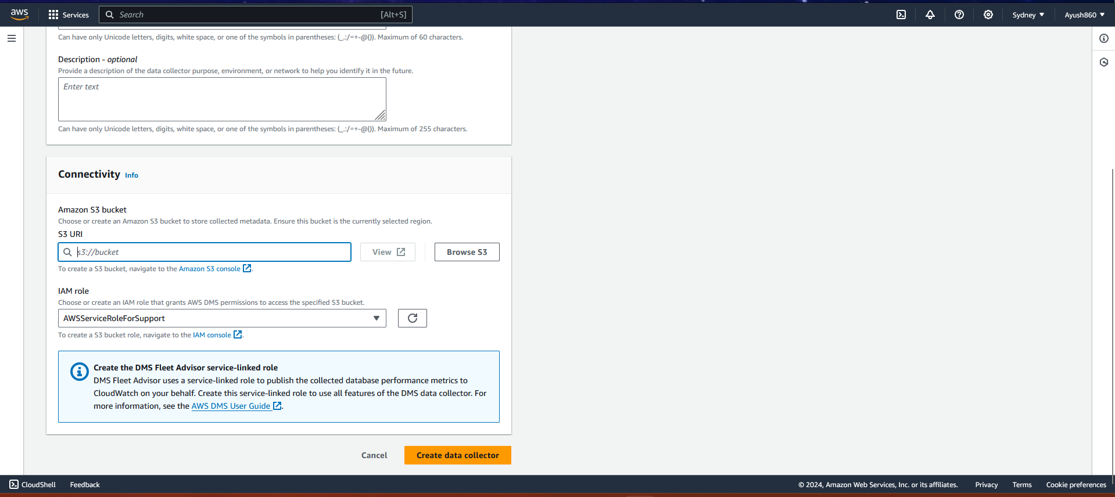

Click on create data collector

